Freshwater Tropical Fish Species and Saltwater Fish Species
The following fish profiles are provided compliments of various online communities (always a good place to start looking). My most useful reference when starting out was found at http://badmanstropicalfish.com/fish_chart.html/. But the following lists are equally useful, with this first list naming the most common species in alphabetical order.

List of Fish Species in Alphabetical order

African Butterfly Fish
Albino Bristlenose Pleco
Albino Cory Cat
Albino Red Fin Shark
Angelfish
Axelrods Rasbora
Bala Sharks
Betta Fish Care(Siamese Fighting Fish)
Black Neon Tetra
Black Skirt Tetra
Bleeding Heart Tetra
Bloodfin Tetra
Blood Red Tetra
Boesemani Rainbowfish
Bolivian Ram Cichlid
Bristlenose Pleco
Bronze Corydoras
Cardinal Tetra
Celebes Rainbowfish
Celestial Pearl Danio
Chela Dadiburjori
Chinese Algae Eater
Clown Killifish
Clown Loach
Common Pleco
Congo Tetra
Convict Cichlids
Dash Dot Tetra
Denison Barb
Discus Fish
Dwarf Gourami

False Julii Corydoras
Firemouth Cichlid
Flying Fox Fish
German Blue Ram
Giant Danio
Glass Catfish
Glowlight Danio
Glowlight Tetras
Gold Gourami
Gold Lyretail Killifish Aphyosemion Australe
Gold Tetra
Guppies
Harlequin Rasbora
Jack Dempsey Fish
Javanese Ricefish
Kissing Gourami
Kribensis
Marble Hatchet Fish
Neon Tetra
Panda Cory
Peppered Corydoras
Red Bellied Piranha
Red Dwarf Rasbora Microrasbora Rubescens
Red Fin Shark
Red Rainbowfish
Rosy Barb
Rummy Nose Tetra
Serpae Tetra
Silver Dollar Fish
Silver Tip Tetra
Spotted Blue Eye Pseudomugil Gertrudae
Striped Panchax
Threadfin Rainbowfish
Tiger Barb
Tinfoil Barb
Wrestling Halfbeak
Zebra Danio

The following list of common fish is broken down by common name and then by species. It’s good to know your fish species’ scientific name to avoid confusion when referring to them with different people.
We can't stress enough the need for hobbyists to research any and all fish before purchasing them! Don't make that impulse buy when shopping for your fish if you don't know its care requirements. You are only doing a disservice to yourself and the animal.
Freshwater Aquarium Tropical Fish  Species Profiles  Anabantoids - Bettas and Gouramis  Betta  Blue Gourami  Dwarf Gourami  Kissing Gourami  Mahachai Betta  Pearl Gourami  Sparkling Gourami  Archerfish  Archerfish  Arowana  Silver Arowana  Butterfly Fish  African Butterfly Fish  Catfish  Chinese Algae Eater  Corydoras Catfish  Iridescent Shark  Otocinclus Catfish  Plecostomus  Zebra Pleco  Characins - Tetras  Black Neon Tetra  Black Phantom Tetra  Black Skirt Tetra  Bleeding Heart Tetra  Bloodfin Tetra  Buenos Aires Tetra  Cardinal Tetra  Head and Tail Light Tetra  Glowlight Tetra  Neon Tetra  Piranhas  Pristella Tetra  Red Belly Pacu  Red Colombian Tetra  Red Eye Tetra  Rummy Nose Tetra  Serpae Tetra  Silver Dollar  White Skirt Tetra  Cichlids  Afra Cichlid  Angelfish  Blue Ram Cichlid  Cockatoo Cichlid  Convict Cichlid  Discus  Firemouth Cichlid  Jack Dempsey  Jewel Cichlid  Kenyi Cichlid  Kribensis Cichlid  Oscar  Blood Red Parrot Cichlid  Polit Cichlid  Red Devil Cichlid  Yellow Lab Cichlid  Zebra Cichlid  Cyprinids - Barbs  Bala Shark  Cherry Barb  Gold Barb  Goldfish  Harlequin Rasbora  Koi  Odessa Barb  Rainbow Shark  Red Tail Shark  Rosy Barb  Scissor Tail Rasbora  Tiger Barb  Tinfoil Barb  White Cloud  Mountain Minnow  Zebra Danio  Hatchet Fish  Marble Hatchet Fish  Killifish  Killifish  Loaches  Clown Loach  Dojo Loach  Hillstream Loach  Kuhli Loach  Livebearers  Endlers Livebearer  Guppy  Mollies  Platy  Swordtails  Freshwater Invertebrates  Crayfish  (aka Crawfish or Crawdad)  Ghost Shrimp  Gold Inca Snail  Mormyridae  Elephantnose Fish  Brackish Water Fish Profiles  Columbian Shark  Figure 8 Puffer  Green Spotted Puffer | Saltwater Aquarium Fish  Species Profiles  Large Angelfish  Emperor Angelfish  French Angelfish  Queen Angelfish  Dwarf Angelfish  Bicolor Angelfish  Coral Beauty Angelfish  Eibli Angelfish  Flame Angel fish  Pygmy Angelfish  Blennies  Lawnmower Blenny  Butterfly Fish  Copperband Butterfly Fish  Lined Butterflyfish  Longfin Bannerfish  Raccoon Butterfly Fish  Cardinal Fish  Banggai Cardinal Fish  Pajama Cardinal Fish  Clownfish  Clownfish (Ocellaris)  Maroon Clownfish  Tomato Clownfish  Damselfish  Blue Damselfish  Blue Green Chromis  Blue Reef Chromis  Three Stripe Damselfish  Yellowtail Blue Damselfish  Dottybacks  Orchid Dottyback  Striped Dottyback  Dragonets  Ocellated Dragonet, Scooter Dragonet  Eels  Snowflake Moray Eel  Goby, Gobies, Dartfish  Diamond Goby  Neon Goby  Purple Firefish  Yellow Watchman Goby  Grammas & Basslets  Fairy Basslet, Royal Gramma  Hawkfish  Marine Invertebrates  Chocolate Chip Starfish  Coral Banded Shrimp  Emerald Crab  Hermit Crab  Nassarius Snail  Peppermint Shrimp  Skunk Cleaner Shrimp  Turbo Snail  Tridacna Clam - Crocea Clam  Jawfish  Yellowhead Jawfish  Lionfish  Lionfish  Radiata Lionfish  Porcupine & Puffer Fish  Porcupine Puffer Fish  Rabbitfish  Magnificent Foxface Rabbitfish  One Spot Foxface Rabbitfish  Sea Basses  Peach Anthias  Seahorses  Common Seahorse  Great Seahorse  Tangs & Surgeonfish  Convict Tang  Moorish Idol  Naso Tang  Orange Shoulder Tang  Pacific Blue Tang  Pacific Sailfin Tang  Powder Blue Tang  Purple Tang  Red Sea Sailfin Tang  Unicorn Tang  Yellow Tang  Trigger Fish  Picasso Triggerfish  Sea Anemone Species  Bubble Tip Sea Anemone  Condy Anemone  Saltwater Wrasses  Harlequin Tuskfish  Six Line Wrasse  Hard Coral  Acanthastrea  Birdsnest Coral  Candy Cane Coral  Frogspawn Coral  Montipora Capricornis  Soft Coral  Pulsing Xenia  Ricordea Florida Coral  Zoanthids - Button Polyps

For a simpler, at-a-glance look into fish compatibility, I refer to the following chart. It contains most of the more common freshwater fish and is conveniently divided into three relevant categories:
Community Fish – Unless marked with a note, these fish can safely cohabitate in the same aquarium.
Semi-Aggressive – Usually peaceful when small, but can become nippers or chase the others around the tank when they get bigger. If you really want to put one of these fish in your community tank, keep an eye on them.
Aggressive Fish – Do NOT mix these fish with any other type fish except similar-sized aggressive fish. They will bully and/or eat smaller, more timid fish.

Category | Community | Semi-Aggressive | Aggressive
Anabantids | Dwarf Gourami  Flame Gourami  Opaline Gourami  Pearl Gourami  Siamese Fighting Fish/Betta(1)  Spiketailed Paradisefish | Honey Gourami  Kissing Gourami | Black Paradisefish
Catfish | Banjo Catfish  Bristlenose  Chinese Algae Eater  Corydoras  Green Catfish  Leopard Catfish  Plecostomus  Spotted Catfish  Upside Down Catfish | Bumble Bee Catfish
Charachins | Black Neon Tetra  Black Phantom Tetra  Cardinal Tetra  Congo Tetra  Emperor Tetra  Flame Tetra  Glowlight Tetra  Head & Tail Light Tetra  Neon Tetra  Rummy Nosed Tetra  Serpae Tetra  Hatchetfish  Pencilfish  Bloodfin  Penguin Fish  X-Ray Fish | Bleeding Heart Tetra  Black Widow  Buenos Aires Tetra  Silver Dollar | Red Belly Piranha
Cichlids | Angelfish  Blue Acara  Discus (2)  Festivum  Ram | Firemouth  Severum | Convict  Green Terror  Jack Dempsey  Red Oscar
Killifish | Lyretail
Livebearers | Guppy  Molly  Platy | Swordtail | Knife Livebearer
Loaches | Clown Loach  Dwarf Loach  Horseface Loach
Unclassified | Australian Rainbowfish  Boesmani Rainbowfish  Boesman's Rainbowfish  Bumble Bee Goby  Elephant Nose  Rainbowfish | Archer  Freshwater Puffer | Butterfly Fish

(1) ONLY ONE male Siamese Fighting Fish/Betta per tank. Two Males will fight to the death if they’re in the same tank! You can have multiple females in the tank.
(2) Discus should not be kept with other fish other than catfish, loaches, neons, or
cardinal tetras due to their high susceptibility to disease. They require a warmer water temperature (85 degrees F), can be sometimes slow eaters, and will not fight for food.
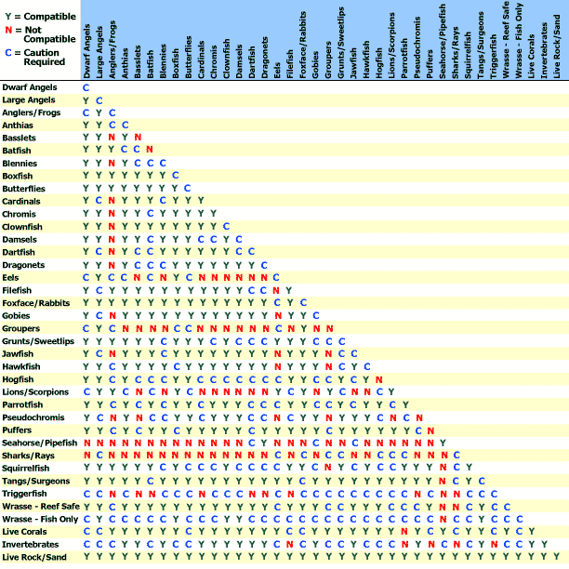
Finally, I offer this popular look at common compatibilities. This page is a good one to print out and refer to whenever you’re thinking about adding a new dimension to your tank. But regardless of whatever chart you reference, always be sure to manually monitor any new additions you make to your fish environment.

